**CN vs MCIc – Z axis**



**Approach 1 - 2019_04_03_14_48**

**Network:**

Transfer learning from AlexNet changing last 3 layers.

|  |  |
| --- | --- |
| **Training parameters:**   * folds=3; * miniBatchSize = 30; * learningRate = 1e-4; * maxEpochs=10; * optimizer='sgdm'; | **Dataset:**   * nSlices=6; * gap=2; |

**Results:**

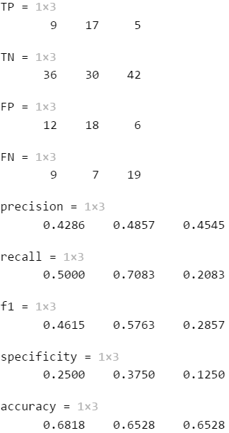

AvarageAccuracy = 0.6625

**Approach 2 - 2019_04_03_15_25**

**Network:**

Transfer learning from AlexNet changing last 3 layers.

|  |  |
| --- | --- |
| **Training parameters:**   * folds=3; * miniBatchSize = 30; * learningRate = 1e-4; * maxEpochs=20; * optimizer='sgdm'; | **Dataset:**   * nSlices=6; * gap=2; |

**Results:**

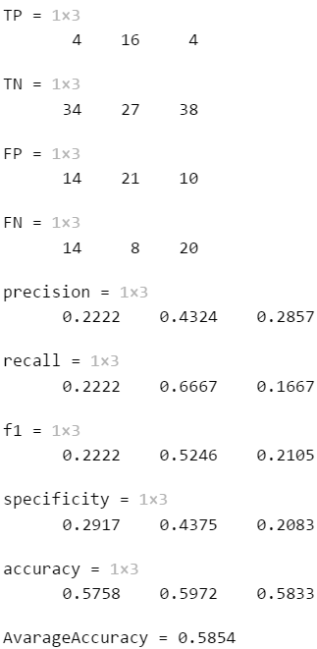

**Approach 3 - 2019_04_03_16_37**

**Network:**

Transfer learning from AlexNet changing last 3 layers.

|  |  |
| --- | --- |
| **Training parameters:**   * folds=3; * miniBatchSize = 64; * learningRate = 1e-5; * maxEpochs=20; * optimizer='sgdm'; | **Dataset:**   * nSlices=6; * gap=2; |

**Results:**

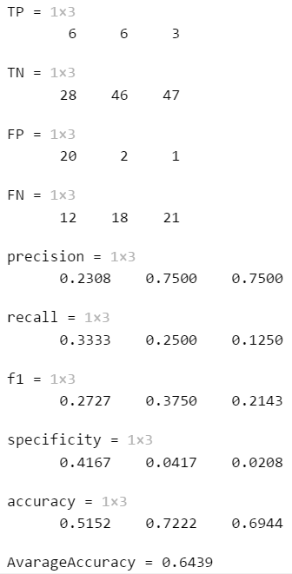

**Approach 4 - 2019_04_03_17_18**

**Network:**

Transfer learning from AlexNet changing last 3 layers.

|  |  |
| --- | --- |
| **Training parameters:**   * folds=3; * miniBatchSize = 64; * learningRate = 1e-5; * maxEpochs=40; * optimizer='sgdm'; | **Dataset:**   * nSlices=6; * gap=2; |

**Results:**

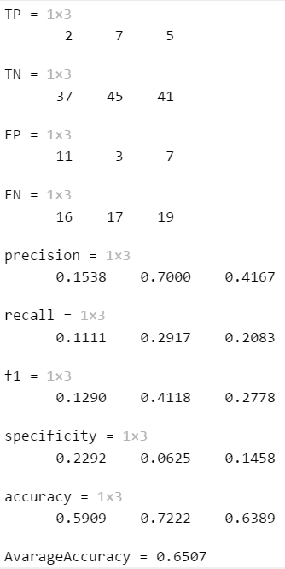

**Approach 5 - 2019_04_04_14_03**

**Network:**

Transfer learning from AlexNet changing last 3 layers.

|  |  |
| --- | --- |
| **Training parameters:**   * folds=3; * miniBatchSize = 64; * learningRate = 1e-5; * maxEpochs=30; * optimizer='sgdm'; * "L2Regularization",1e-03 | **Dataset:**   * nSlices=6; * gap=2; |

**Results:**

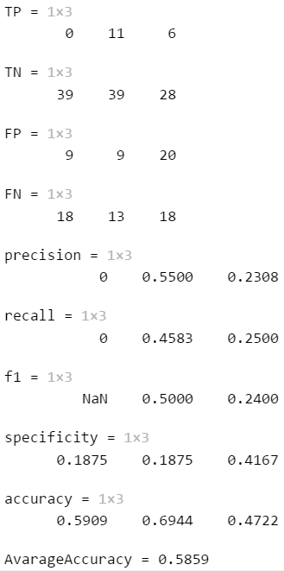

**Approach 6 - 2019_04_04_15_00**

**Network:**

Transfer learning from AlexNet changing last 3 layers.

|  |  |
| --- | --- |
| **Training parameters:**   * folds=3; * miniBatchSize = 64; * learningRate = 1e-5; * maxEpochs=40; * optimizer='sgdm'; * "L2Regularization",1e-04 | **Dataset:**   * nSlices=6; * gap=2; |

**Results:**

